Ideation Phase
Brainstorm & Idea Prioritization Template

Date | 18 June 2026
Team ID
Project Name | SHOPEZ : E-commerce Application
Maximum Marks | 4 Marks

Brainstorm & Idea Prioritization Template:
Step-1: Individual Ideation and Problem Statement Selection

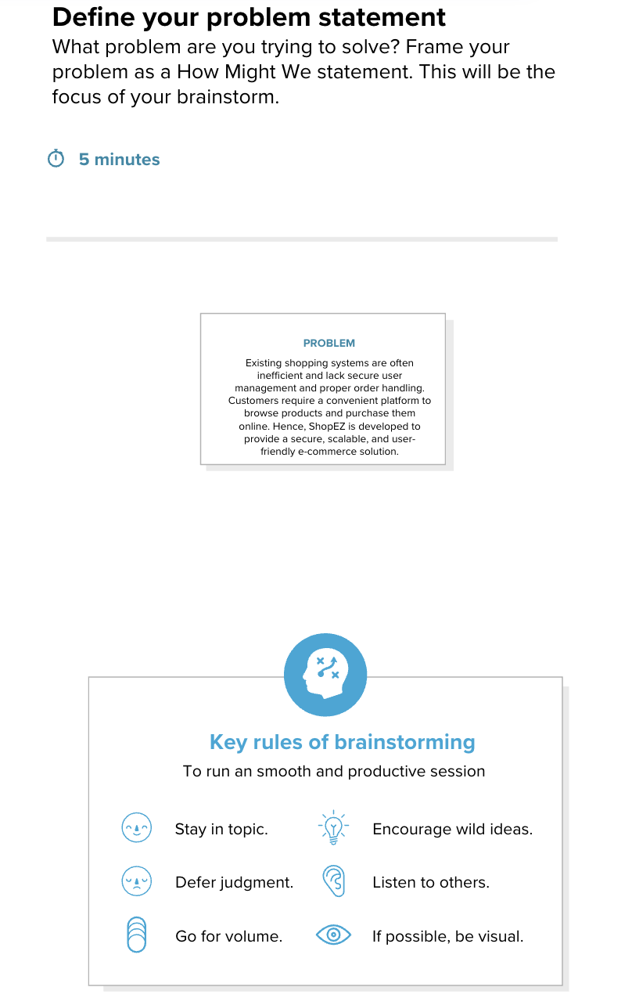

Step-2: Brainstorm and Idea Listing

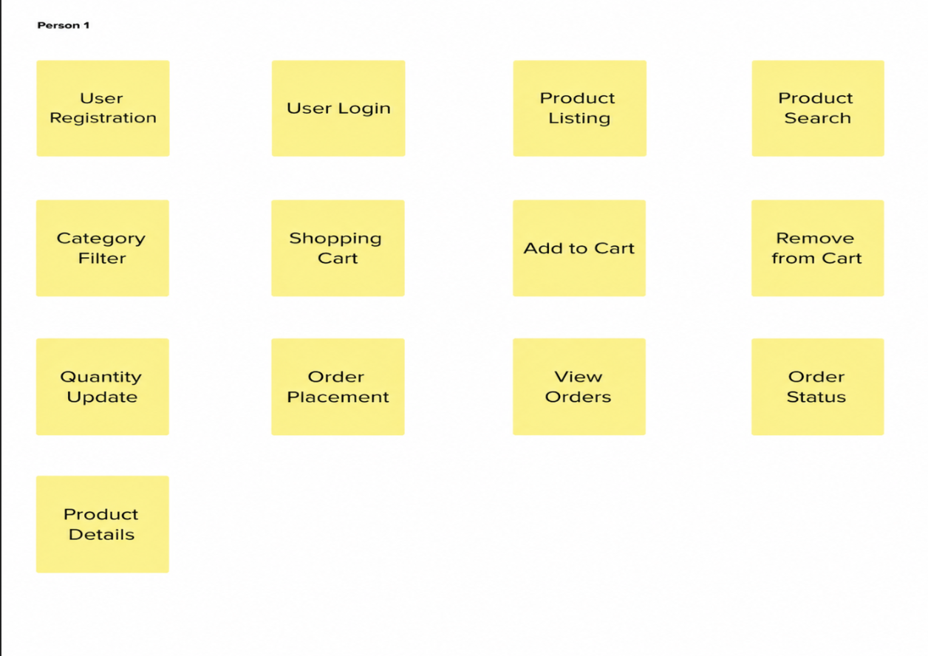

Step-3: Idea Prioritization

